Minimum sum of product:
import java.util.Scanner;
import java.util.Arrays;
class Main {
public static void main(String[] args) {
Scanner sc = new Scanner(System.in);
int n = sc.nextInt();
int[] a=new int[n] ;
int[] b=new int[n];

for(int i = 0; i < n; i++){
a[i]= sc.nextInt();
}
for(int i = 0; i < n; i++){
b[i] = sc.nextInt();
}
int sum=0,k=0;

Arrays.sort(a);
Arrays.sort(b);
for(int i = 0; i < n; i++){
k=a[i]*b[n-1-i];
sum=sum+k;
}
System.out.println(sum);
}
}
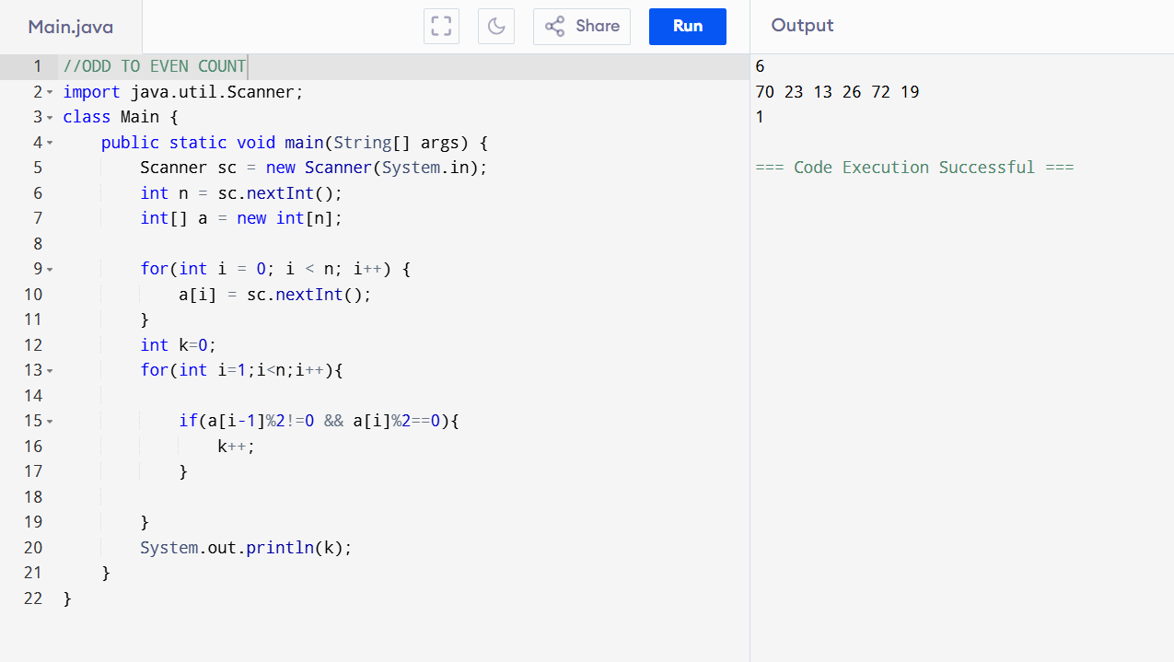
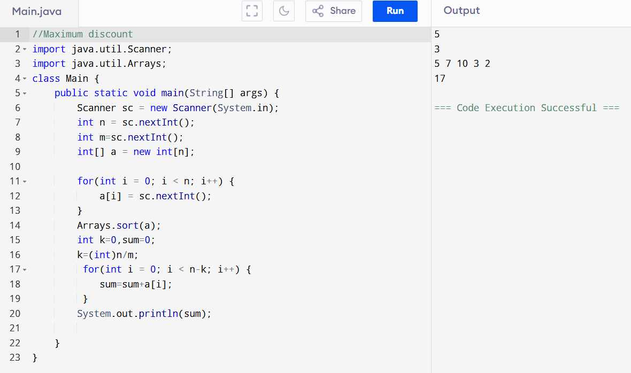

3. You need to arrange books in a lib with the help of students. Each stu has a collection of books .bookshelves can hold a maximum of k books and must be fully filled. If a student has more books than shelf capacity.the excess books carry over to the next students shelf.if they have fewer books those books also carry over to the nexts students shelf. your task is to return an integer value that the tot number of bookshelves that can completely decked by the books
inp 1: no of students
Inp 2: k represents max no of book shelf
Inp 3:array represents the no of books each student have

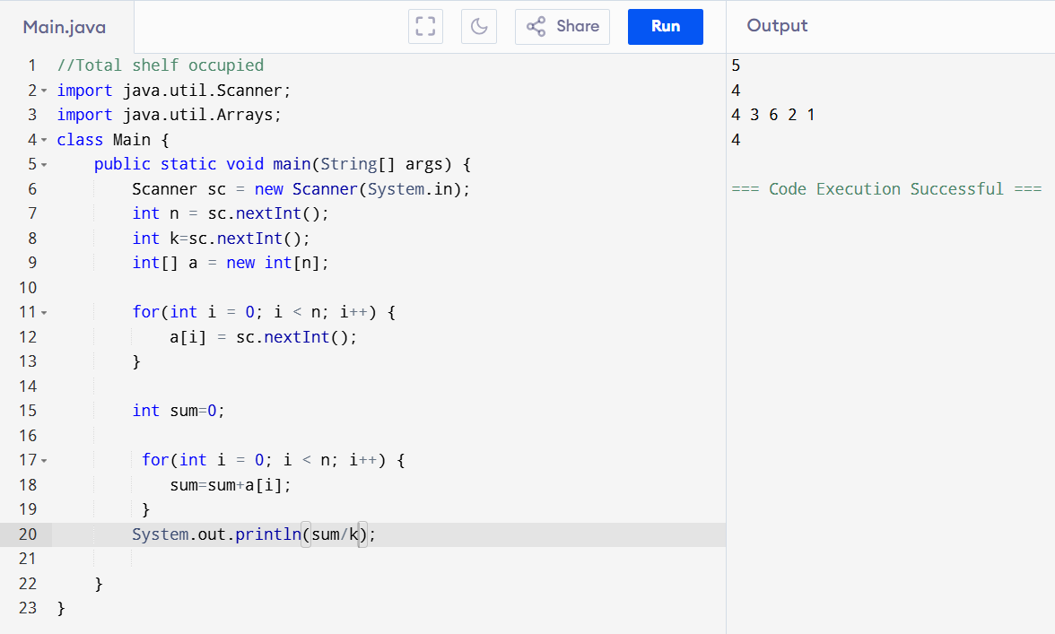

4. N students and you want to divide them into two groups for the trip.however,you gave a special requirement one group should only consist of students wih even numbered IDS and the other group should only consist of students with odd numbered IDs and both the groups must be of the same length.your task is to find and return int value of the max no of students that can be included in both grps
Inp 1:N represents total no of students
Inp 2:int arr containing IDs pf students
[2 3 5 4 6]=[2 4 6][3 5]
Smallest [3 5] so even should equal to size of that [2 4]=ans is 4

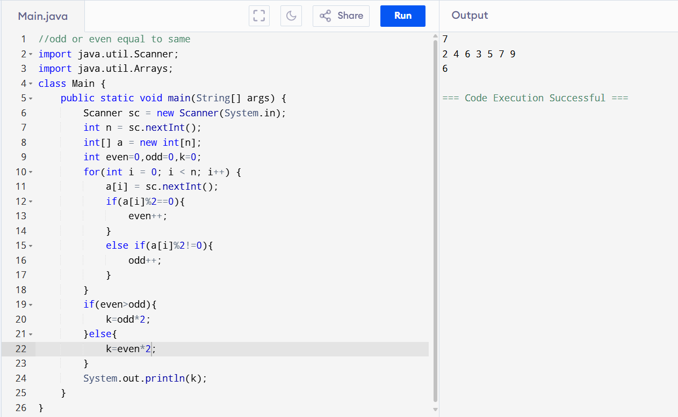

5. There is a lift in a society that can accommodate a max weight of X units.the weights of the people planning to use the lift are given in an integer array A of size N . Your task is to find an int value representing the maximum no of people that can use the lift together without exceeding its weight capacity.
Inp1 : N no of people
Inp 2: X value of max weight cap of lift
Inp 3: A array contains the weights of the people to use the lift
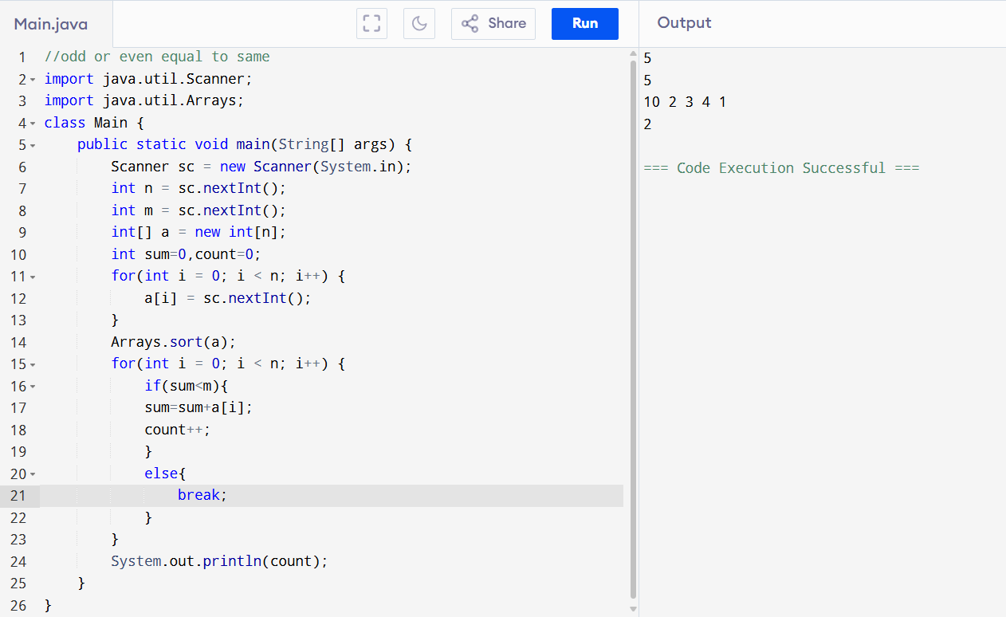

6. String S comprises of only X and Y. In order to make it an ideal string she wants to remove any repetitive alphabtes from the string. This means that one X should follow one Y and so on.
In order to clean the string.she is allowed to remove each extra X or Y one at a time. Find and return the minimum number of removals she needs to perform to achieve her ideal string.
Inp1: XYXXYXXY
Output=2

Problem Statement – Vohra went to a movie with his friends in a Wave theatre and during break time he bought pizzas, puffs and cool drinks.
Consider the following prices :
• Rs.100/pizza • Rs.20/puffs • Rs.10/cooldrink
Generate a bill for What Vohra has bought.
Sample Input 1: • Enter the no of pizzas bought:10 • Enter the no of puffs bought:12 • Enter the no of cool drinks bought:5
Sample Output 1: Bill Details • No of pizzas:10 • No of puffs:12 • No of cooldrinks:5 • Total price=1290 ENJOY THE SHOW!!!

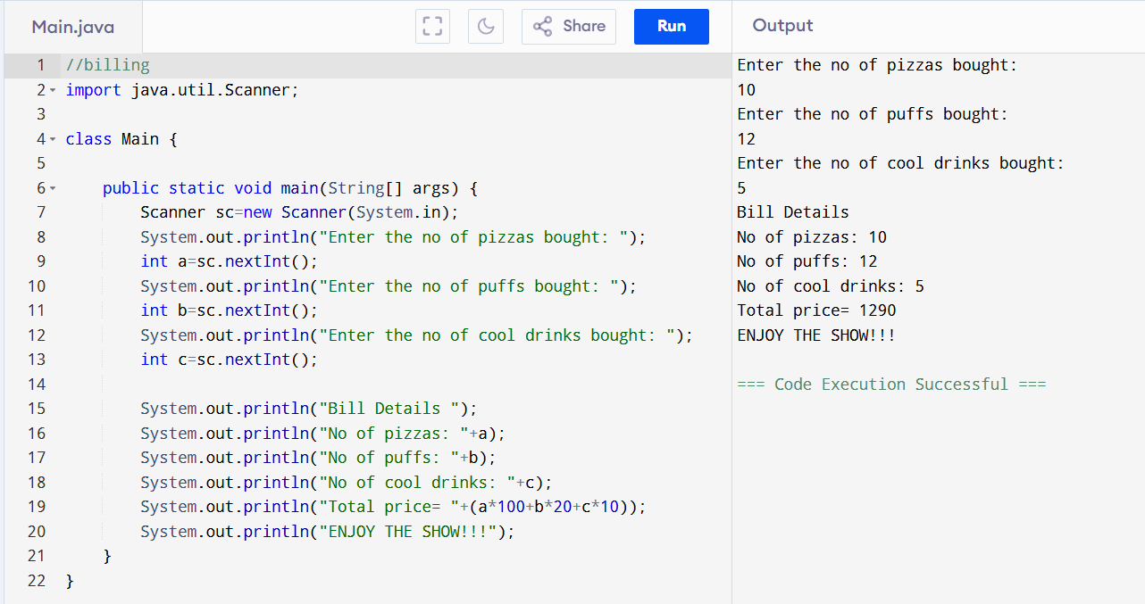

A consist of fruits obtained in each tree.[4 3 2]
Then 4 is planted 3 fruits are obtained ,then 3 is planted 2 fruits obtained likewise until 0
Mul 4*3=12 sum 3*2 sum 2*1 -> a[1]
Final sum total no of fruits obtained

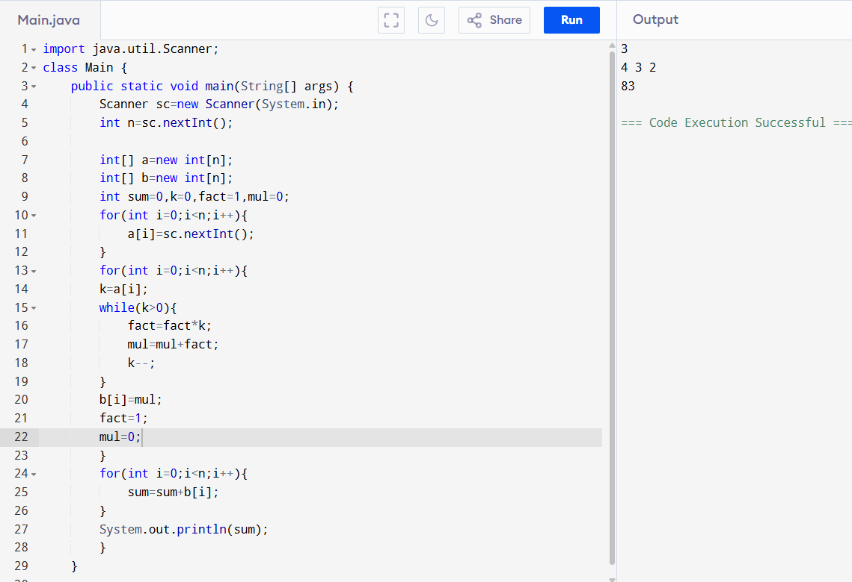

Encapsulation:
class Vending Machine {
// 1. HIDDEN DATA: Locked inside the machine (private)
private int totalSnacks = 10;

// 2. THE GETTER: A safe window to view the data
public int getSnacksCount() {
return totalSnacks;
}

// 3. THE SETTER: A safe button to change the data with rules
public void buySnack() {
if (totalSnacks > 0) {
totalSnacks--; // Decrease snacks by 1
System.out.println("Snack dropped! Enjoy your treat.");
} else {
System.out.println("Sold out!");
}
}
}
public class Main {
public static void main(String[] args) {
VendingMachine machine = new VendingMachine();

// ❌ THIS WILL FAIL (Direct theft is blocked)
// machine.totalSnacks = 0;
// Error: totalSnacks has private access!

// THIS WORKS (Using the safe window to look)
System.out.println("Snacks available: " + machine.getSnacksCount());

// THIS WORKS (Using the safe button to buy)
machine.buySnack();

// Check the count again
System.out.println("Snacks left: " + machine.getSnacksCount());
}
}

